**Artificial Intelligence (CS607P)**

Assignment # 02  
**Fall 2022**

**Solution:**

**Question 1:**

CLIPS operate by maintaining a list of Factsand a set of Ruleswhich operate on them. Facts on their own are of only limited use. The application of Rules is necessary to develop a program capable of some useful function and this can be achieved by using rule-based programming. Write a program in CLIPS IDE to generate the given below rule and add a fact that will fire the added rule and use the facts command to see the index of total facts present in working memory both prior and after running of rule.

**Generate a Rule:**

**IF**  Rainy Day

**THEN**  Carry Umbrella

You are required to send the output in the form of screenshot using CLIPS IDE

**Screenshot:**

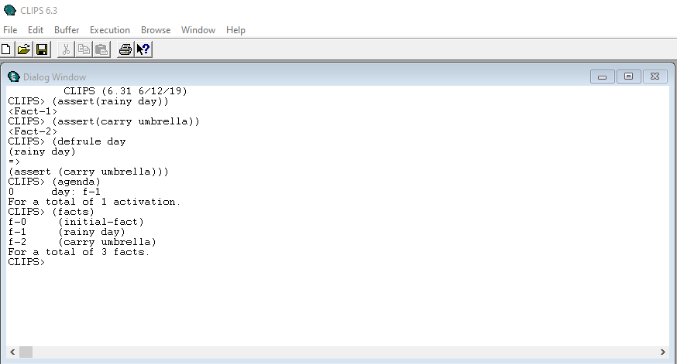

**Question 2:**

Write the program in CLIPS IDE that will save the facts about grocery products (at least 5 products). You are required to make fact list of items. After loading the facts in working memory use the facts command to see the index of product facts. Remove fact 3 by using the relevant command and again use the facts command to see the index of remaining product facts. You are required to send the output in the form of screenshot using CLIPS IDE

**Screenshot:**

